Workshop: Mapping Immigration Using Social Explorer

Objective: We will use the Social Explorer demography data visualization interface to take snapshots of the changing demographic patterns in the neighborhood immediately surrounding your chosen site for ethnographic research. Use the snapshots to prepare a PowerPoint presentation describing how a specific Asian cultural-linguistic population has changed over time.

Steps
- Use Social Explorer as described below to acquire 5 screenshots of the changes over time in the demographics around your location.
- During or after the workshop, add these 5 images to the provided PowerPoint assignment template (1 image per slide).
- On the last slide, write 2–4 sentences that describe the overall immigration patterns the images depict. (For example, you might write: “The neighborhood immediately surrounding the temple is primarily Caucasian, but the temple is located between two neighborhoods that are currently 40% and 60% Asian. Both neighborhoods began to see an increasing number of Thai residents beginning in 1990, and steadily increased until plateauing in 2010. A slight decrease in the Thai population is noted in 2015.”)
- Each student will briefly present their PowerPoints in class on the day marked in the syllabus.

How to Set Up A Screen Shot
- Click the “Split Screen” icon located in the lower middle portion of the map and choose “Side by Side.”
- For the left side, go to “Change Data” and select:
  - 1980
  - Race > Asian and Pacific Islander
- For the right side, go to “Change Data” and select:
  - 1980
  - Asian & Hispanic Groups > [Ethnicity associated with your temple]
  - If country of origin is not applicable or available, use “All Asian.”
- Click the “lock” icon in the top center of the page.
- Search for your location’s address on both sides so the markers appear on the map.
- Zoom out so you have an adequate view of the census tracts around your address.
- Take a screen shot:
  - Mac: Shift + Command + 4
  - PC: Control + Print Screen
  - Chromebook: Control + Window Switch Key
- Save the acquired images a USB drive (note they will be deleted from the computers in the lab), or copy the images directly into your PowerPoint presentation.
- Repeat these steps for the years 1990, 2000, 2010, and 2015.

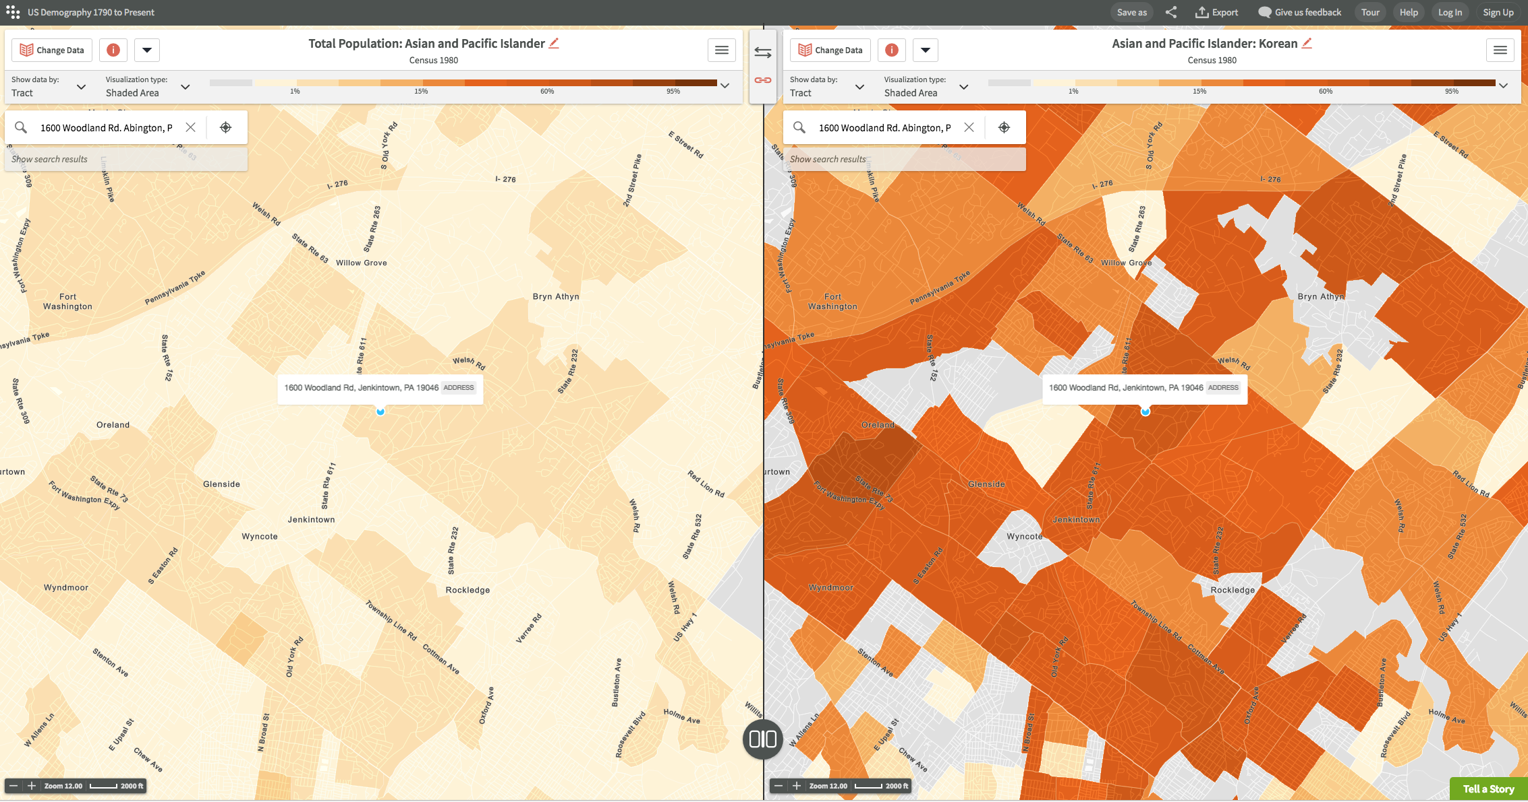

Tips
- Look at the language that is used to categorize people, so as to note differences between different years.
- Zoom in and out to see how the data is reported at different levels. Choose the most informative scale for your screen shot.
- You can hover over different tracts to get the exact data, such as population numbers and percentages.
- Librarians are available to help you during the workshop with any technical difficulties.

