Mapping Immigration using Social Explorer

Objective: To observe how Asian populations have changed over time in the neighborhood immediately surrounding a targeted Buddhist temple.

Activity/Assignment:
- For a given temple location on the map, you will use Social Explorer to take snapshots of the changing demographic patterns in a specific Asian cultural-linguistic group to show patterns of immigration over time.
- You will save the acquired images a USB drive (note they will be deleted from the computers in the lab) or will copy the images directly into the PowerPoint presentation.
- During the workshop or after class, add these 5 images to the provided PowerPoint assignment template (1 image per slide).
- On the last slide, write 2–4 sentences that describe the overall immigration patterns the images depict. (For example, you might write: “The neighborhood immediately surrounding the temple is primarily Caucasian, but the temple is located between two neighborhoods that are currently 40% and 60% Asian. Both neighborhoods began to see an increasing number of Thai residents beginning in 1990, and steadily increased until plateauing in 2010. A slight decrease in the Thai population is noted in 2015.”)
- When complete, upload the PowerPoint presentation to the appropriate inbox on Canvas.

Navigating to Social Explorer:
http://libraries.psu.edu >
Databases Tab > S > Social Explorer > Start Now > [Skip the tour]
[To use this tool, you must enable Flash on your computer.]

Using Social Explorer:
- Click the “split screen” icon located in the lower middle portion of the map and choose “side by side.”

For the left side:
- Go to Change Data and select:
- 1980
- Race > Asian and Pacific Islander

For the right side:
- Go to Change Data and select:
- 1980
- Asian & Hispanic Groups > [Ethnicity associated with your temple]

- Click the “lock” icon in the top center of the page.
- Search for your address on both sides so the markers appear.
- Then zoom out so you have an adequate view of the tracts around your address.
- Take a screen shot
  - Mac: Shift + Command + 4
  - PC: Control + Print Screen
  - Chromebook: Control + Window Switch Key
- Paste this into the PowerPoint assignment template or another file such as a Google presenation.

Repeat these steps for the years 1990, 2000, 2010, or 2015.

Tips:
- Remember to look at the language that is used to categorize people, so as to note differences between different years.
- If country of origin is not applicable or available, use All Asian.
- Zoom in and out to see how the data is reported at different levels.
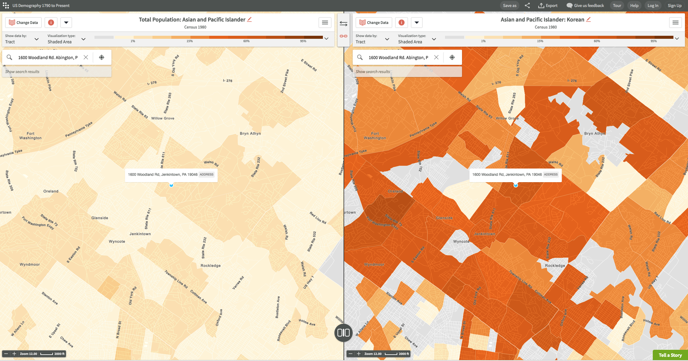
- You can hover over different tracts to get the exact data, such as population numbers and percentages.

